**Morgan Stanley**

**Business Analyst**

**Location: New York, NY (July’10- Present)**

### Implementation & Development

___________________________________________________________________________________

The company operates in three primary business segments: institutional securities (capital raising, corporate lending, financial advisory services for corporate and institutional investors); global wealth management group (brokerage and investment advisory services, financial planning for individual investors and businesses); and asset management (asset management services and products including alternative investments, equity, fixed income; merchant banking; investment activities)

**Project:** Morgan Stanley deployed full services for complete banking solutions for their clients. I was involved in creating fixed income and derivates platform for their client login website.

**Environment:** Rational Rose, Rational Requisite Pro, MS Office Suite, MS Project Plan, Oracle 10g,MS SharePoint, Business Objects

**Responsibilities:**

* Strong Financial Domain knowledge in **Fixed Income & Derivatives**
* Solid experience in fixed income trading with estimation of Coupon Rate, Current Yield, and YTM.
* Performed Fixed Income Analysis (Pricing, Risk, Yield, Duration, and Recommended Strategy) with Excel to support trading and reviewed with portfolio manager and traders.
* Advance knowledge of stock derivatives – Futures/Options(Calls/Put) and margin money concept
* Managed requirements from system users and preparation of business requirement documents using Rational Requisite Pro that provided appropriate scope of work for technical team to develop prototype and overall system.
* Created UML based diagrams using Rational Rose for Use Cases and **Activity Diagrams**, for better understanding of the layout of the new process.
* Assisted the Project Manager in preparing the **Project Development Plans**
* Involved in identifying and tracking Project Issues and Risks.
* Gathered the functional and business requirements by conducting JAD sessions and participatory Design Sessions involving major leads from the Technical Department.
* **Gathered requirements** and participated in database design and development as well as report design and development, testing plan co-development and quality assurance.
* Developed Business Requirement Document and Use Cases Specification for various Use Cases.
* Performed data conversion, stratification and quality control testing of interim and final data and preparation of all reports and data transmissions to client for projects.
* Extracted data from Oracle into temporary tables in order to cleanup and standardize column entries for re-import into new Oracle data structures. Used extensive ad-hoc queries (SQL) to create/modify/delete data.
* Created UAT test scenarios and test cases and coordinated UAT.
* Generated Executive Problem Management Reports in Excel.
* Helped many business clients in getting right and precise information for making better decision.

**James Gorman : CEO**

**Location 1585 broadway**

**Time :july 2010- present**

Morgan Stanley deployed full services for complete banking solutions for their clients. I was involved in creating fixed income and derivates platform for their ClientLink page.

**Client LINK** is a private, secure Internet platform connects our institutional and Private Wealth Management clients to Morgan Stanley research, trading, financial applications and other proprietary information, as well as account reporting.. Since it was a client – server based application. I was part of the maintenance and enhancement team working on multiple projects simultaneously.

**ClientLINK** ,the server appl provides users with the tools to track and manage their portfolios online 24/7. The module allows for viewing of account information in real time, to review asset allocation by stocks, bonds , fixed income and derivatives. Users can monitor realized and unrealized gains/losses. The web application utilized industry leading portfolio monitoring and reporting features and provided proprietary research.

**Q. How did you interact with Business Partners and how did you manage priorities?**

I used to interact with business partners on regular basis. I used to keep them in the loop in the status mails of the project. Also I used to Invite them for JAD sessions periodically.

As a business analyst you have to be smart enough to manage priorities. Suppose you get a requirement wherein you are supposed to make BRD’s for small projects/enhancements & BRDs for bigger projects which will take longer time. So you have to prioritize them. I would say if every document is equally important then I would go on finishing on the smaller ones first because once my work is finished then only developers will start their job.

|  |  |  |
| --- | --- | --- |
| **Use Cases** | **Test Cases** | **Bugs** |
| 1.Login to ClientLINK |  |  |
| 2.Access information to the portfolio | 1. clicks on   “track your portfolio”   1. System displays the allocation of the portfolio based on the stocks,derivatives and bonds. 2. C. user monitors unrealized and realized gains/losses | Bug found during the display of gains/losses System was taking too much time compared to that mentioned in BRD. |
| 3) Check whether correct information is displayed |  |  |
|  |  |  |

**Were you involved in UAT for this application?**

A: I was involved in UAT in almost every project I am involved in. In this project I had taken over complete Functionalities of validating test in order to support the QA team.

RUP ,Oracle 10g database for extracting data using SQL

**Draw a use case for me**

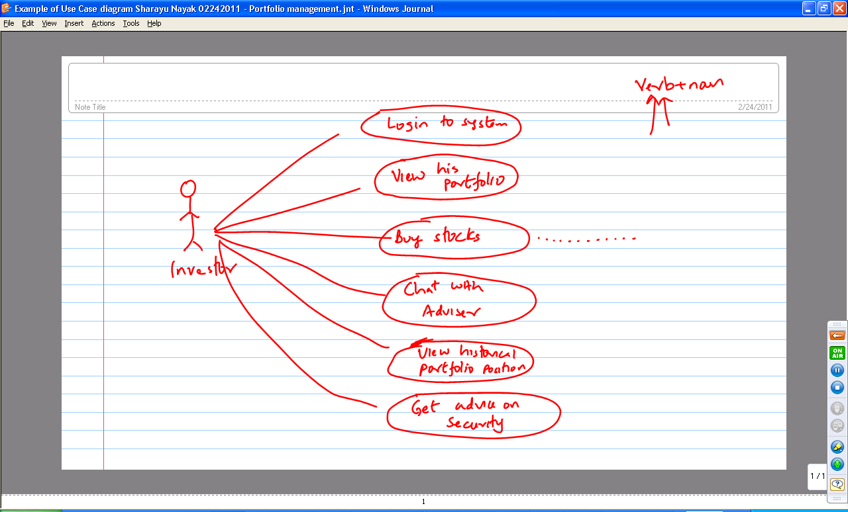

**Draw a process diagram for me**

